SEND information Report
How we support children/young people with Special Educational Needs or Disabilities.
Our Vision:
We are a community school that provides an aspirational learning environment for all our students, regardless of their specific needs. We are committed to enabling all our students to achieve their full academic potential and to develop into an independent and confident member of society.
Langdon Park School is an inclusive mainstream secondary school. We admit students from ages 11-19 including our Sixth Form.

We also have staff with specialised expertise and qualifications in school including:
- Accredited SENCO.
- First Aid trained Teaching Assistants including Epilepsy emergency training.
- Speech and Language Assistants.
- Literacy Teaching Assistants.

Our fully qualified SENCO actively engages with local opportunities to share best practice and keep abreast of current local and national policy to support pupils with SEND. The school also seeks advice and guidance from local special schools to review, evaluate and develop provisions for young people with complex needs.

HOW WE GIVE OUR STUDENTS A VOICE

All students have opportunities to speak their mind and express their opinions. Students with SEND have key workers who listen to their concerns and they will then act on them. Every student with an Education Health Care Plan (EHCP) has person-centred reviews regularly. Some students may not have an EHCP but require support so they fall under the SEN Support category. We use a variety of methods and approaches to ensure that individual students can express their views and opinions.
Our pupil’s point of view:
You can confide in people, teachers are trustworthy and they explain the work so I can understand.

HOW PARENTS ARE INVOLVED IN SCHOOL LIFE

Parents are consulted at every stage to form effective partnerships in supporting their children.

We will communicate with you through:
- Parents’ evenings
- Progress review days where you can also meet the Teaching Assistant working with your child
- Information events at the school
- Annual reviews and other meetings with the SENCO or a member of the team
- Phone calls and letters home
- Interpreters are provided for all school events in any language requested
- Newsletters
- Positive examples of work sent home
- Praise postcards and phone call.

IDENTIFICATION – ASSESS, PLAN, DO, REVIEW

We have a rigorous referral, assessment and monitoring progress which ensures that all students who are not making expected levels of progress or who have needs affecting their ability to engage in learning are identified.

All teachers have been trained on this process as part of our staff training and are aware that new SEND concerns now need to be discussed with Heads of Faculty /Year Leaders and an initial SEND screening completed by the staff member making the referral. If further investigation or assessment is required, the SENCO will liaise with parents and other professionals.

An individual Education Plan (IEP) will be written which sets out the support your child will receive. This will include your child’s strengths as well as their difficulties. An IEP will also include any advice or recommendations from external agencies. This will then be shared with staff, parents and most importantly the young person.

Review meetings are held as required. Parents, relevant external agencies and students are invited to an annual review as we believe their contribution is valued. The impact of the support offered is considered along with the progress towards targets set. Support arrangements will be updated and revised accordingly. This might include referrals to external agencies, if they are not already involved.

If your child is continues to have significant difficulties, further external expertise may be requested. Additional funding is available for young people who meet the criteria. This needs to be agreed using the Local Authority process and the guidance in the Banded Funding Criteria. Where this is agreed, an Education, Health and Care (EHCP) plan will be drawn up and implemented with support from external agencies and other professionals where appropriate.

TRANSITION

The SENCO liaises with all primary schools in Year 6 by visiting the schools and the students who are identified as needing additional support. Transition plans are then put in place reflecting the needs of all students. Students with a high level of need will be placed in one of our groups; Transition group or Nurture group, which is staffed by specialist SEN teachers.

All staff members are made aware of students with SEND on the first day in September and of adjustments that may be needed within lessons or around the school. Parents will be informed during the first term if their child is identified as SEN and an appointment with the SENCO will be offered to discuss their needs.

We conduct a screening test early in Year 7 to help identify any students who will need additional support with literacy. This is repeated annually to Year 9. All students who score below the expected level at the end of KS2 will have additional Literacy support in Year 7 in the form of ‘catch up groups.’

If parents have any concerns about their child’s transition to secondary school they can contact the SENCO whose details are listed below.

ACCESS ARRANGMENTS
Access Arrangements (AAs) are pre-examination adjustments for candidates based on evidence of need and normal way of working. AAs allow candidates with special educational needs, disabilities or temporary injuries to access the assessment without changing the demands of the assessment. In this way Awarding Bodies will comply with the duty of the Equality Act 2010 to make reasonable adjustments.

When students are in Year 9, they are all given a screening test and anyone with a standardised score below eight-five will be further assed by a specialist teacher. Therefore, appropriate access arrangements would be requested. These include extra time, a scribe/word processer or a reader/computer reader and in some case an Oral Language Modifier (OLM).

INTERVENTIONS

Students will be given support appropriate to their need. Support interventions for student with SEND may include:

Cognition and Learning Needs

- Working with TA to accommodate the individual needs of the young person.
- TA’s developing strong collaborative relationships with teachers by creating a Partnership Agreement.
- Entry Level courses for core subjects (English, Science and Maths)
- Literacy intervention groups.
- Read write Inc. (RWI) programme including 1:1 support and catch up where necessary.
- Differentiated ability settings for RWI.
- 1:1 support.
- Accelerated Reader.
- Transition and Nurture groups.
- 6th form Foundation learning course.
- Specialist teacher support in class based lessons.
- Online literacy programmes.
- Language and comprehension Ruth Miskin.
- Special exam Access Arrangements.
- Specialist work experience.
- Partnership work with Tower Project, New City College and One by Me.

Communication and Interaction needs

- ASDAN/Life skills teaching.
- Service Level Agreement (SLA) with the Speech and Language Service
- Speech and language therapist advice disseminated to and followed by teaching staff.
- Access to Elklan trained TAs.
- Phoenix outreach programme.

Social, Emotional and Mental Health Difficulties

- Working with Trailblazers.
- Whole school mental health screening.
- Working with University based intervention – UCL.
- Educational Psychologist – CBT intervention.
- Social stories.
- SocialEyes.

Sensory and Physical Needs

- Full wheelchair accessibility.
- Lifts in all buildings of the school.
- Disabled toilets and changing facilities.
- Ancillary equipment for students with a disability.

Pastoral, Learning Support and Intervention Teams meet regularly to identify support for students who are not making expected levels of progress or who are experiencing difficulties which are preventing them from engaging in learning.

Various tracking systems are in place for interventions being carried out at school so the impact of interventions can be closely monitored and changes made where necessary.

THE SENCO, LEARNING SUPPORT STAFF AND TEACHERS ARE RESPONSIBLE FOR:

Coordinating provision for young people with SEND.

Tracking and monitoring the progress of young people with SEND.

Ensuring parents are kept informed about the range and level of support offered to their child; including reviews about their child’s progress and transition to a new key stage, group or provision.

Liaising with a range of agencies outside of school who can offer advice and support to help students overcome any difficulties.

Providing specialist advice and facilitating training to ensure all staff are skilled and confident in meeting a range of needs.

STAFF RESPONSIBITIES AND INCLUSIVITY

We are proud that we are a responsive team and we adapt our curriculum according to the needs of the students. Our Sixth form course is also tailored to the needs of our students.
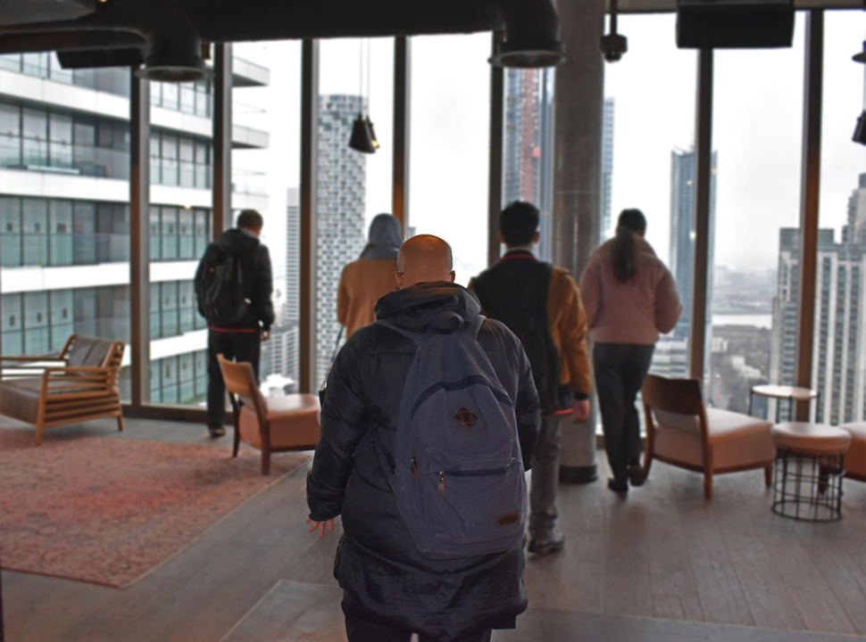

We make use of assistive technology wherever necessary, for example, the use of C-Pens (exam reader equipment).

Teachers have a responsibility to adapt their lessons to the specific needs of their students; considering the range of SEND. They are given information about all the students they teach including more detailed information about students with SEND. If the need is high and the student is unable to access the mainstream curriculum, a student will be in a specialist group with an SEND teacher for some lessons. All students will do practical lessons including Arts, Technology and PE with their mainstream class. Teaching Assistants support students with both ECHPs and those on SEND Support in both mainstream and withdrawal groups.

The SENCO co-ordinates support for all students with medical needs and disabilities in collaboration with the designated safeguard lead (DSL). The school aims to put in place all reasonable adjustments necessary to support individual students. Information is carefully and sensitively shared with school staff. Some students’ needs will be managed by other pastoral staff in the school, depending on the need.

Medication is kept in a locked area in the school office and administered or taken under supervision by the Medical Welfare Officer.
There is a fortnightly highlighting meeting which is led by the Designated Safeguarding Lead (DSL) in the school and attended by the SENCO, Learning Mentors, the school based Social Worker, the Attendance and Welfare Officer and the school Police Officer. During these meetings students who are causing concern are highlighted and a plan of action is agreed.

HOW WE DECIDE WHAT RESOURCES WE CAN GIVE TO A YOUNG PERSON WITH SPECIAL EDUCATIONAL NEEDS

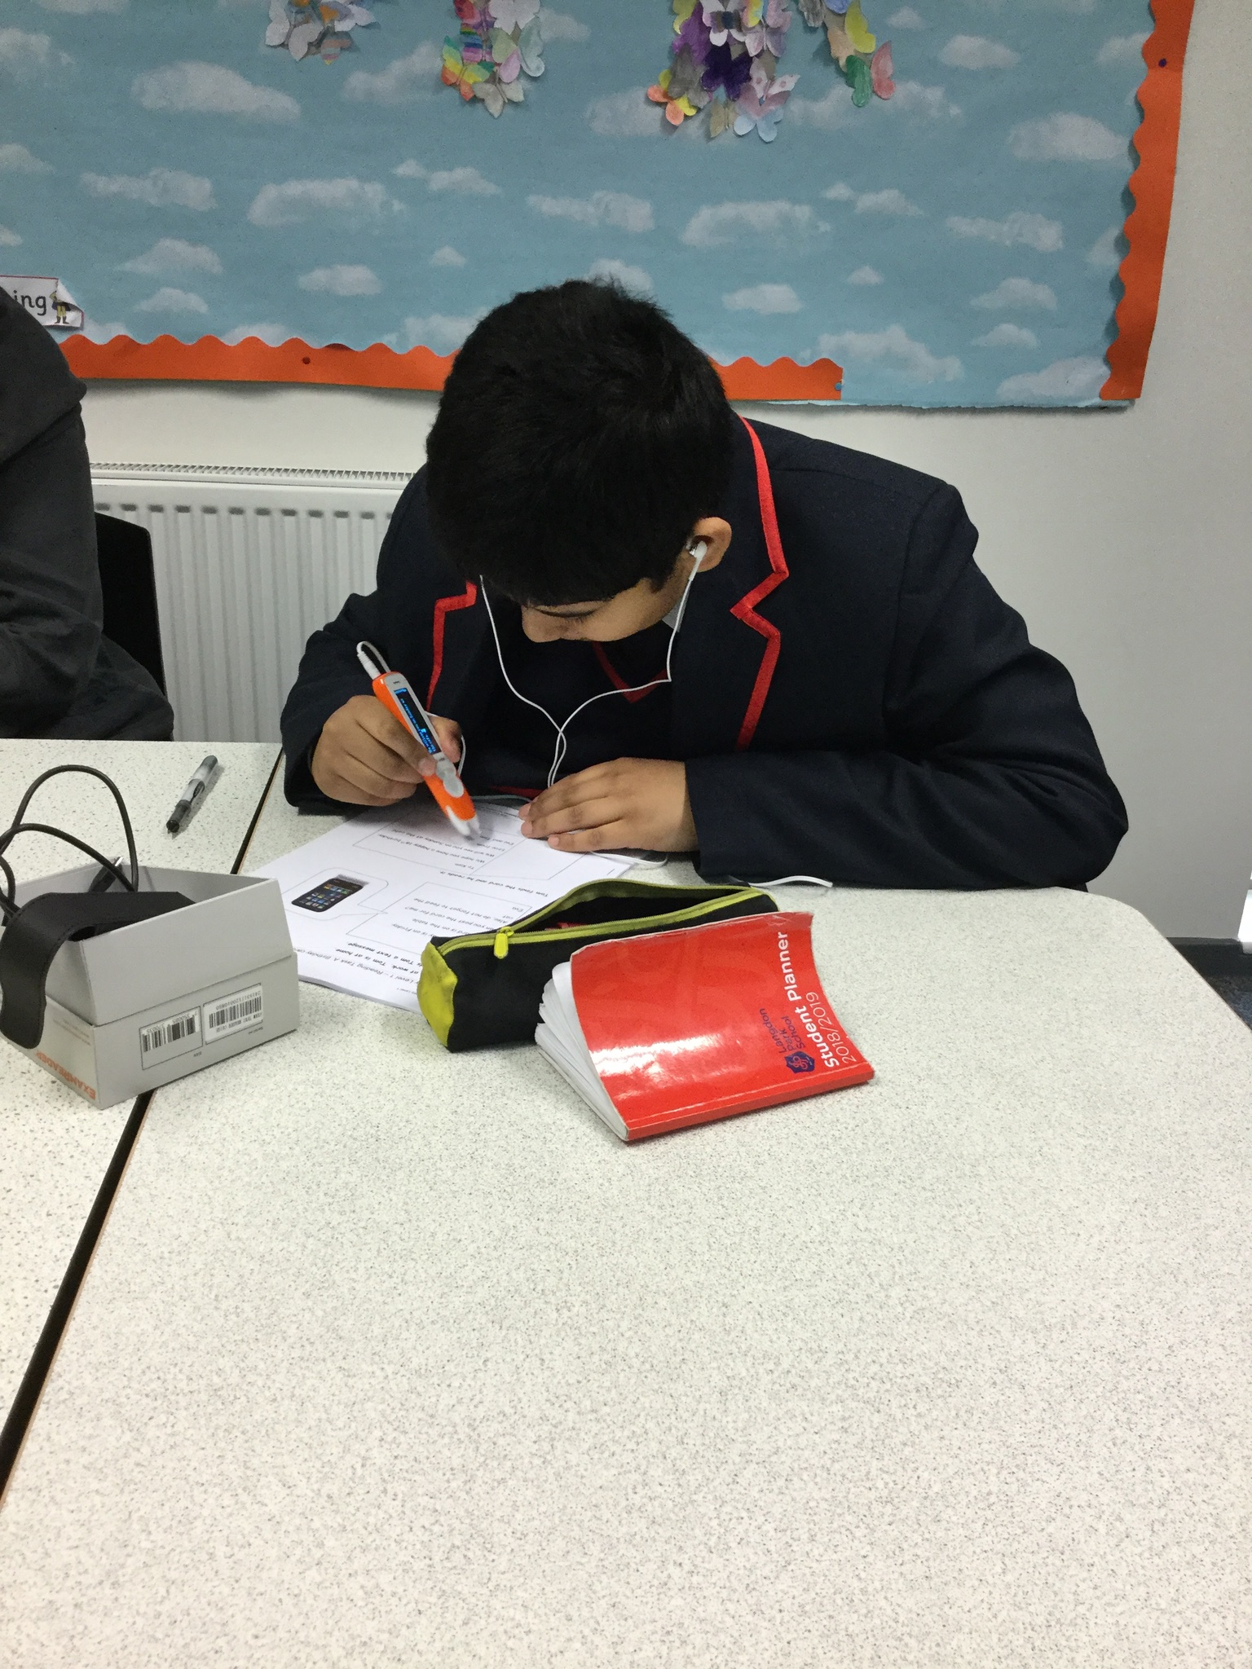
A specialist SEND team delivers a range of support as described above. Resources for specific students will be allocated according to their need. We will use additional funding from EHCP as a guide to determine the resources needed; this could include Teaching Assistant support; small groups; ancillary aids; work with an outside agency for example.

All decisions about resources and budgets will be agreed at the students planning meeting and will be reviewed regularly. The system will be reviewed as described in the graduated approach (Assess, Plan, Do, Review)

The school will measure the effectiveness of the interventions from a range of information including progress data and informal reports. The decision to start or continue with an intervention will be taken at the student’s review meeting.

HOW WE TRACK PROGRESS

- The school makes regular checks on progress through the reporting of levels, currently three times a year. The SENCO will report to parents of students with ECHPS formally in addition to whole school reports.
- Students in intervention groups have their progress tracked by the specialist teacher and ultimately the SENCO. This information will form the basis of the Annual Review where progress and future outcomes will be discussed.
- Parents will be informed about specific interventions and how they can help their child at meetings with the SENCO and other Learning Support staff. Each student’s key teacher will advise parents on how they support learning at home, through additional and appropriate reading texts for example.
- Team around the child (TAC) hold regular meetings to discuss the needs of the student.
- TAs keep progress trackers that are regularly shared to inform staff on the best support and intervention.

SPECIALIST EXTERNAL SERVICES WE USE

Langdon Park works closely with the Local Authority that provides:

Educational Psychology services for assessment and support.
The Support for Learning Service for advice and assessment for a range of Special needs and disabilities.
The Behaviour Support Team for advice, assessment and support.
The school nurse/health.
Speech and Language Therapy service.
CAMHS (Child and Adolescent Mental Health Services)
Phoenix Outreach for support with ASD.
The Parents Advice Centre (PAC)
Children’s Social Care.
The Careers Service.

We also work with other local providers:

Tower Project who offer employability options for our SEN students.
One By Me (Work under the Tower Project umbrella delivering a fashion course)
New City College.

STAFFING EXPERTISE
How skilled are staff in meeting the needs of my child?

Langdon Park prides itself on ensuring that teachers deliver high quality lessons. Learning Support staff regularly attend training programmes to develop their quality of teaching and support for students with SEND.

Recent training has covered:
- Speech and Language development.
- Individual Education Plans.
- Disability awareness training.
- Interventions.
- Safeguarding.
- Autism Spectrum Disorder.
- Downs Syndrome.
- Access arrangements.
- Speech, language and communication needs.
- Literacy.
- SEMH.
- Manual and Handling
- Specialist Dyslexia teacher who has the AMBDA (Associate membership of the British Dyslexia association).
- Speech, language and communication needs specialist Teacher. She also has an MA in SEN.
- A qualified psychotherapist.
- All our SEN Teachers are fully qualified and have been judged good or outstanding teachers.
- We have three higher level Teaching Assistants and many who are trained to NVQ level 3.
- English as an Additional language.

We also train staff in:
- Child protection/ safeguarding training
- Restraint training
- Use of Access arrangements in exams
- Oral language modifier training
- Allergies and eczema
- Epilepsy
- First aid

INCLUSIVITY IN SCHOOL AND OUTSIDE SCHOOL
We have a daily lunch and break time club where vulnerable students can attend. This is staffed by TAs and safe games and play is encouraged.

All students are included in school trips and relevant vigorous detailed risk assessments are carried out three weeks before. Parents are informed in advance of a school trip and are expected to leave emergency contact numbers with the school and provide any important information, such as medical conditions in advance.

We organise trips for students with SEND and we have developed good links with the Museum of London who offer specialist SEND workshops in Docklands and the Barbican. Outreach organisations such as Tower Project are of great importance as they offer off-site learning. Travel Training for students who lack the confidence to travel independently is recommended as well as enrichment activities SEND students.

The careers service meets with every child with an EHCP from Year 9 to advice on option choices and programmes for Post-16 and beyond. Our Foundation learning programme in the 6th form is designed as a bridge between school and college as students will have the opportunity to sample different options for employment and training through our partner providers.

CONTACT INFORMATION

Headteacher: Nicholas Langham | langhamn@langdonpark.org

If you have concerns about your child please speak to their Year Leader.

Year 7 | James Pearce
Year 8 | Jo Olaye
Year 9 | Gulden Rifat
Year 10 | Evelyn Morrison
Year 11 | Gary Bulleyment
Assistant Head KS5 | Matthew Farrow
YLC Years 12/13 | Sarah Jane Gordon

You may then be directed to one of our Learning Support teachers, the SENCO or other members of the intervention team.
SENCO: Memory Kampiyawo | kampiyawom@langdonpark.org | 0207 987 4811 etx. 219
Deputy SENCO & 6th Form FV Lead: Sasha Sappleton-Stone | sappleton-stones@langdonpark.org
School’s Education Psychologist:  Jack Hammond | Jack.Hammond@towerhamlets.gov.uk
School’s Speech Therapist:  Lydia Dobie | Lydia.Dobie@bartshealth.nhs.uk
Phoenix Outreach:  Athina Stamou | astamou1.211@lgflmail.org
Tower Project:  Jamie Crouch | Jamie.Crouch@towerproject.org.uk
Medical Welfare Officer:  Noorun | Nmiah22.211@lgflmail.org
Safeguarding Lead:  Mary O’Brien | obrienm@langdonpark.org

